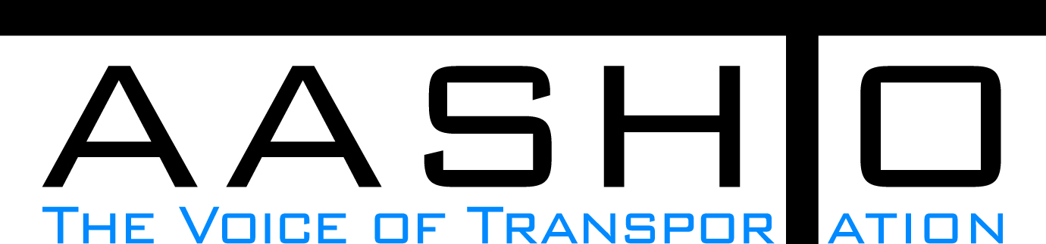Domestic Scan Proposal Form
AASHTO is soliciting topic proposals for a Calendar Year 2013 US Domestic Scan Program (NCHRP Panel 20-68A). Each selected scan topic will be investigated through site visits to three to six locations for approximately a two week period or less (type 1), by webinar (type 2) or peer exchange (type 3) conducted by a group of eight to 12 transportation professionals with expertise in the selected topic area. Proposed topics should meet the following criteria:
- Address an important and timely need for information by transportation agencies;
- Are of interest to a broad national spectrum of people and agencies;
- Are complex and also “hands-on,” meaning they lend themselves particularly well to exploration through on-site visits; and
- Are sufficiently focused that the tour participants are able to investigate and understand key issues in the limited time available on the tour.
This form is designed to collect the full length of your proposal. Sections requiring essays have unlimited space for you to use. Contact information has some limited text. Use your TAB key to advance to the area where you need to complete information.
Proposals should be returned no later than OCTOBER 15, 2012.
Proposal Contact Information
Name | Erica Interrante (on behalf of Mary Lynn Tischer) | Address | 1200 New Jersey Ave., SE, Washington D.C., 20590
Title | Transportation Specialist | E-mail | erica.interrante@dot.gov
Member Department | FHWA Office of Policy, Transportation Studies | Telephone number | 202-366-5048
AASHTO Committee |  | Date of submission | October 12, 2012

Title of Proposed Scan

Accelerating Broadband Infrastructure Deployment

Problem Statement (What topic is to be examined? What drives the need for the scan? Why now?)

On June 14, 2012, President Barak Obama signed an Executive Order to facilitate the deployment of broadband technology on Federal lands, buildings, rights of way (ROW), federally-assisted highways and tribal lands. This Executive Order brings together federal agencies who are involved in decisions related to access of Federal property and rights of way to reduce barriers to the expansion of broadband services in underserved communities located on or in proximity to these properties.
Specific to the USDOT, the Order advises the DOT to reach out to states, local governments and tribal lands on implementing best practices on matters pertaining to the installation of underground fiber conduit along rights of way on federally-assisted highways. The Order also advises the DOT to review and revise (if necessary), its guidance to State DOTs to allow for profit and other entities to accommodate or construct broadband facilities on State and locally-owned ROW. A scan on state and local issues relating to broadband deployment would complement the DOTs effort in compiling existing information, input and recommendations on current polices, procedures and practices on this topic, as well as highlight best practices in the deployment of broadband services which utilize highway ROW around the country.

Scan Scope (What specific subject areas are to be examined? Which cities and states might be visited? Which agencies/organizations (including specific departments or types of staff if applicable)?

The scope will include the following areas to be examined:
--A review of "dig once" policies and/or requirements
--Using private investment in State ITS infrastructure
--Determining fair market value for ROW on federally-assisted highways and/or incorporating an analysis of the benefits
--Reestablishing any highway assets disturbed by installation
--Ability to incorporate changes in broadband technologies and markets
--Promoting competitive broadband and infrastructure deployment (i.e. redundancy)
--Issues and/or obstacles relating to the deployment of broadband facilities among the states

Cities or states to be visited (proposed):

Oklahoma, New York (i.e. New York Thru Way), California (San Francisco, Santa Monica), Kentucky, Louisiana, Boston, MA, Philadelphia, PN

Agencies/Organizations to participate (proposed): FHWA, RITA-JPO, AASHTO, State DOTs, NTIA, Department of Commerce, APA, NACO, NADO, National League of Cities, APWA, USTA

Anticipated Scan Results (What key information is to be gained? What information is to be shared after the scan? Who would the audience be for this information?)

Key information to be gained: Identification and discussion of best practices in the deployment of broadband as it relates to federally-assisted highways. Awareness of key issues and/or obstacles states and local areas are facing when deploying broadband within the ROW. Recommendations for additions and/or changes to policies, procedures and practices at the state, local and federal level to accelerate the deployment of broadband in underserved areas.

Information to be shared: State ROW laws and joint occupancy guidelines and agreements, best cases in broadband deployment; outcomes of the scan on the topics defined above

Audience: State DOTs, MPOs, local area planning commission and/or agencies involved in broadband deployment and/or economic development, private operators of broadband services, federal agencies that have access to properties on federal lands, buildings, highway ROW and tribal lands.

Benefits Expected (Including potential impacts on current technology or procedures)

Reduce barriers to the expansion of broadband services in underserved communities by:
Identifying best practices in broadband deployment
Faciltating the communication between various entities involved in the deployment of broadband services
Identifying the need for any revisions/additions to policy, procedures and requirements
Identifying best practices in engaging the private sector
Promoting competitive broadband and infrastructure deployment

The information will be used to address the tasks outlined in the Executive Order.

